INTRODUCTION

Governmental Statistics show that there are high levels of theft in South Africa. Therefore, there is a need for a way to retrieve stolen goods like vehicles as well as personal property.

Although there are already GPS Tracking devices on the market, most of them are expensive and can only be used for one purpose.

ENGINEERING GOAL

The goal of this project is to design and manufacture a modular GPS tracking device that can accurately track stolen objects from anywhere in the country. The device will be modular allowing the user to add additional functionality to the core tracking module. The device should be mass producible and use pre-existing communication infrastructure to locate the device. There should be no third party involved in locating the device.

In addition to this, a secondary datalogging module will also be created to demonstrate the modularity of the core GPS Tracking device. This module should store location data like routes travelled on an SD Card in a common file format

PROCEDURES FOR CORE MODULE

First, the components that were required to design the core device was chosen. The three main components used in the device is a ***microcontroller*** that interfaces with and controls all the chips, a ***GPS module***, and ***GSM module*** (used to send and receive SMSs)

The schematic and PCB layout was designed in a free CAD software called EasyEDA. The PCB layout was sent to a factory to be fabricated.

After the components were purchased and the PCBs arrived from the factory, the board was assembled.

Software had to be made for the microcontroller so that the device would function properly. The software was created in the Arduino IDE and was programmed in C.

Two cases were designed and printed to house the PCB and make the device more modular. It is designed to make it easier for the other modules to attach to the core module.

Lastly, the device was tested against the design criteria to determine how well it performed.

PROCEDURES FOR DATALOGGING MODULE

As with the core module, the components required had to be chosen first. The main components used in the datalogger is a ***microcontroller*** that controls writing to the ***SD Card***, an ***USB-to-TTL UART Converter*** that makes it possible to update the software of the core module via the onboard ***USB port****.* The power from the USB port is used by the ***charge management IC***to charge ***a 18650 Lithium-Ion battery.***

The schematic and PCB layouts were created next and the PCB layout was sent to a factory to be fabricated.

After the components and PCBs arrived from the factory, the boards were assembled.

A New version of software had to be written for the core module for it to be able to communicate with the microcontroller of the datalogger, which code was also written for so that it can communicate and write data to the SD Card.

Lastly, the secondary datalogging module was tested with the core module against the design criteria to determine how well it performed.

RESULTS

P R O D U C T I O N

Both the core and secondary datalogging devices are contained on single multi-layered PCBs thus these devices can easily be manufactured as PCB fabrication is a very fast and cheap process.

Neither the core or datalogging module uses off the shelf components resulting in a steep drop in the price per unit.

All the components on both the core and datalogger are surface mount components, these types of components are the most common type components used in factories, it can easily be assembled by pick and place machines minimizing the need for human involvement in production (which further decreases production cost).

C O R E M O D U L E

The core device uses SMS to communicate with the user. Thus, it does not require a subscription to a third party.

The core device is modular. The code of the device can be changed and there are 3 programmable pins available for use by other modules added later.

RESULTS

D A T A L O G G I N G M O D U L E

The secondary datalogging module is capable of logging location data in a common file format called GPX. It is the standard format for logging location data and can be used by fitness apps and software map apps.

The device is lightweight weighing only 22 grams without the battery and 68 grams with the battery.

C O M P A R I S O N T O E X I S T I N G T R A C K E R S

|  |  |  |
| --- | --- | --- |
| Criterion | Common GPS Tracker | Modular GPS GSM Tracker |
| Upgradability | Most GPS trackers on the market have a closed ecosystem and are closed source. Software cannot be upgraded and there is no way to add additional hardware to the device. It is impossible to add additional functionality to these trackers | This tracker’s software is open source and can easily be upgraded via a computer. The tracker’s hardware has 3 I/O pins that can be programmed. Third-party developers can create their own hardware and software that adds additional functions to the device |
| Applications | Can be used to track a lot of items including people and vehicles, but other uses are limited. | Can be used to track a lot of items but can also be used for other applications like detecting odd movement of farm animals, notifying the user when the tracker exits a certain region etc. |

APPLICATIONS

Since the core device is modular, it can be used for a variety of applications.

It can be used as a standalone in a vehicle, put inside a wallet or bag or it can be given to a child to monitor his/her whereabouts.

The device works the best outdoors, which narrows the uses of the device if a highly accurate location is required.

The core device can be used with the datalogging module by shipping companies to track the route that a shipment followed. It can be used by truck companies to track where their drivers drove during their shifts, or simply to record/log a workout or vehicle trip.

POSSIBLE EXTENSIONS

Improvements can be made to extend the device’s battery life.

More software can be created to make the user experience better or allow for additional functionality without more hardware and even more modules could be created to add functionality.

The GSM antenna can be put onto the PCB making the assembly process easier.

DISCUSSION

Each prototype of both modules got smaller because as prototypes were developed, the components used for testing the device became unnecessary and were removed leading to a smaller form factor. This also lead to a decrease in current draw.

The core device has several limitations: The device can only get a GPS fix if it is outside unless it is placed near a window. The device will function indoors if an initial GPS fix was gained outside.

The limitations of the datalogging module is that it can only write data to the SD Card, the core module cannot read any data from the SD Card. This issue can be minimized by rewriting the code of the MCU of the datalogger to allow reading from the SD Card as well.

CONCLUSION

According to all the results obtained in this project, the Modular SMS GPS Module designed and manufactured meets the requirements and criteria needed to accomplish the engineering goal. It is modular, uses a low current, is cheap to manufacture and requires no subscription to a third-party company.

The datalogging module designed and manufactured also meets the requirements needed to accomplish the engineering goal. It logs to an SD Card in a common file format and works seamlessly with the core module.

Therefore, in conclusion, the project has achieved its goal.

ACKNOWLEDGEMENTS

* Thanks ***Rochelle and Malan Wykerd*** for funding the research of core module and ***everyone who sponsored money*** for the datalogging module’s research.
* Thanks ***Johann Erasmus*** for soldering the first attempt at assembling the final prototype, helping with the debugging of the final prototype of the core module’s first attempt, and soldering one of the datalogging modules.
* Thanks ***Dr. Danie Ludick (PhD)*** for organizing with the University of Stellenbosch to populate the final prototype of the core module and datalogging module, reading through my designs and helping to debug the first attempt to assemble the final prototype of the core.
* Thanks to ***Grant Parkes*** for giving advice regarding the case design and for arranging the manufacturing of the case.
* Unpopulated PCBs fabricated by ***JLCPCB***.
* ***ALL IMAGES ON THIS POSTER IS TAKEN BY DANIEL WYKERD***
* Poster background watermark retrieved from ***https://openclipart.org/detail/296685/seamless-circuit-board-pattern***

BIBLIOGRAPHY

1. Arduino, n.d.. *ArduinoToBreadboard.* [Online]   
   Available at: https://www.arduino.cc/en/Tutorial/ArduinoToBreadboard  
   [Accessed 13 04 2018].
2. Arduino, n.d.. *Reference GSM Library.* [Online]   
   Available at: https://www.arduino.cc/en/Reference/GSM  
   [Accessed 06 02 2018].
3. SIMCom Wireless Solutions, 2017. *SIM800C Hardware Design.* [Online]   
   Available at: http://simcom.ee/documents/SIM800C/SIM800C_Hardware_Design_V1.05.pdf  
   [Accessed 8 5 2018].
4. Adafruit Industries, 2012. *Learn Adafruit Ultimate GPS Downloads.* [Online]   
   Available at: https://learn.adafruit.com/adafruit-ultimate-gps/downloads  
   [Accessed 5 5 2018].

***FULL BIBLIOGRAPHY IN REPORT FILE***

***DO NOT TOUCH THE ELECTRONICS!***

THE ELECTRONICS ARE ELECTROSTATIC SENSITIVE

MODULAR

GPS GSM

TRACKER

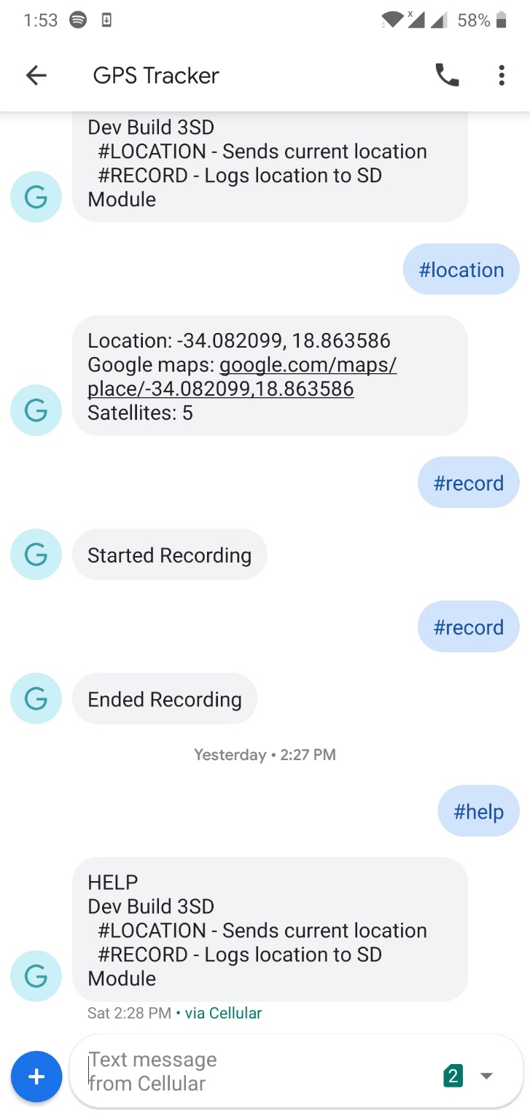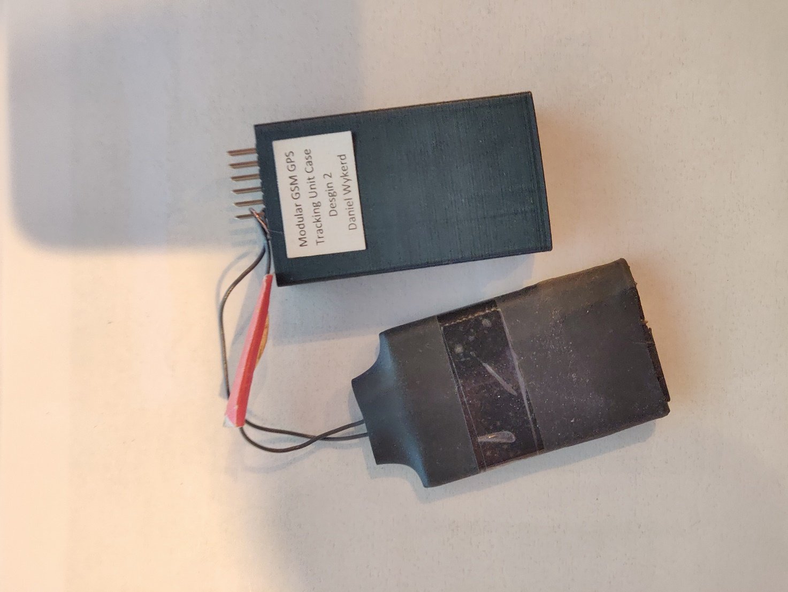

STANDALONE CORE MODULE SETUP

DANIEL

WYKERD

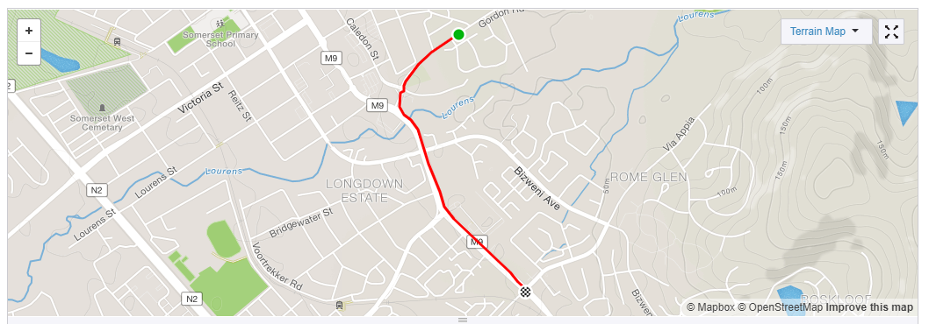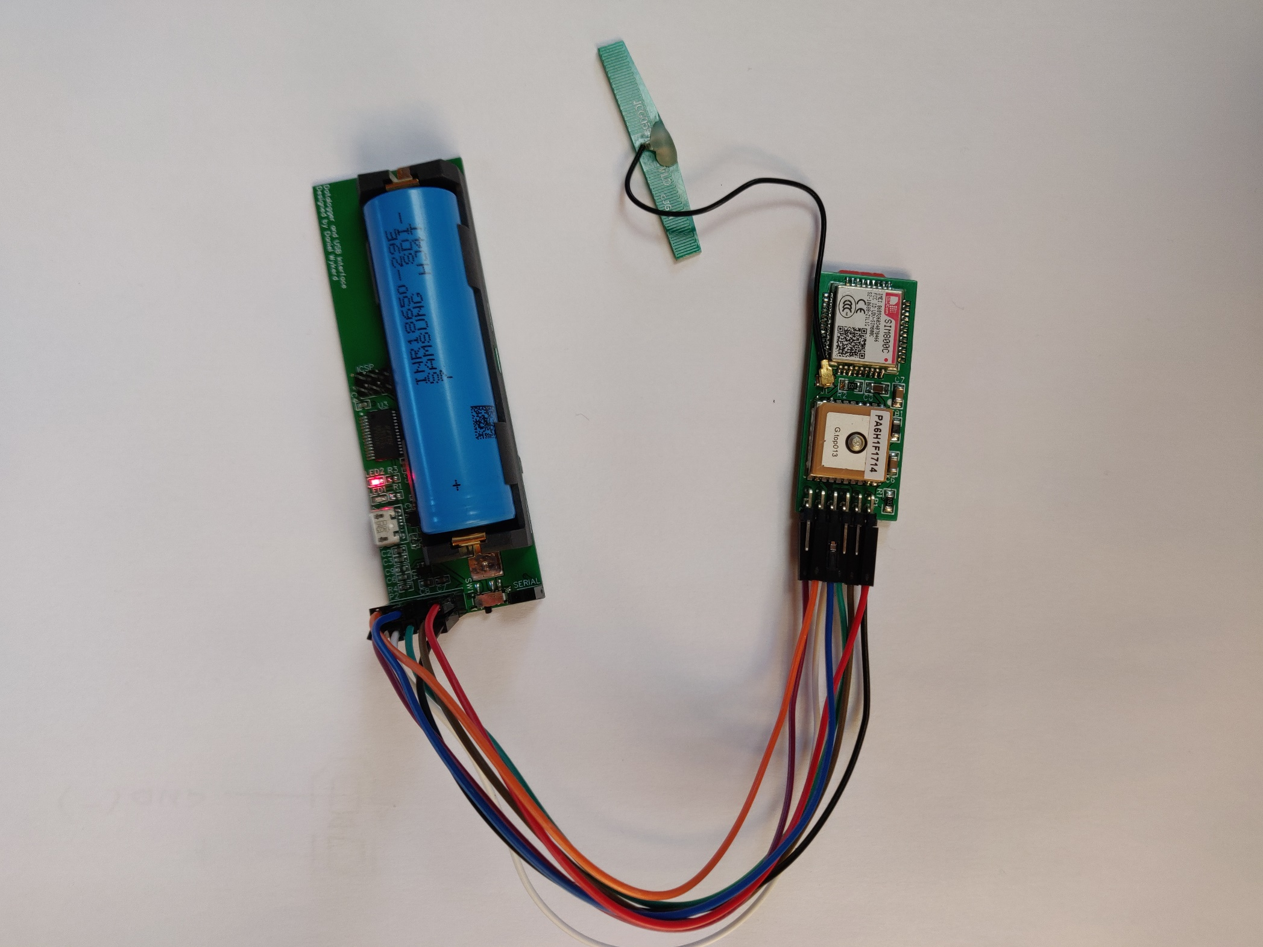

DATALOGGING MODULE SETUP